**CHAPTER FOUR**

**RESULT AND DISCUSSION**

**4.1 INTRODUCTION**

The problem was thoroughly examined at this point in our dissertation, the appropriate technique was employed to identify solutions to the issues the users raised and in this, chapter we will provide the remedies and discuss them.

**4.2 RESULTS**

In terms of outcomes, we will demonstrate the various print screens of our web application in order to determine its functionalities, how it appears in terms of layout, and to gain an understanding of how the system operates internally with the aid of the rules played by the aforementioned actors.

**4.3 PRESENTATION OF SCENARIOS AND A BRIEF EXPLANATION OF EACH SCENARIO**

## 4.3.1 GENERAL HOME PAGE

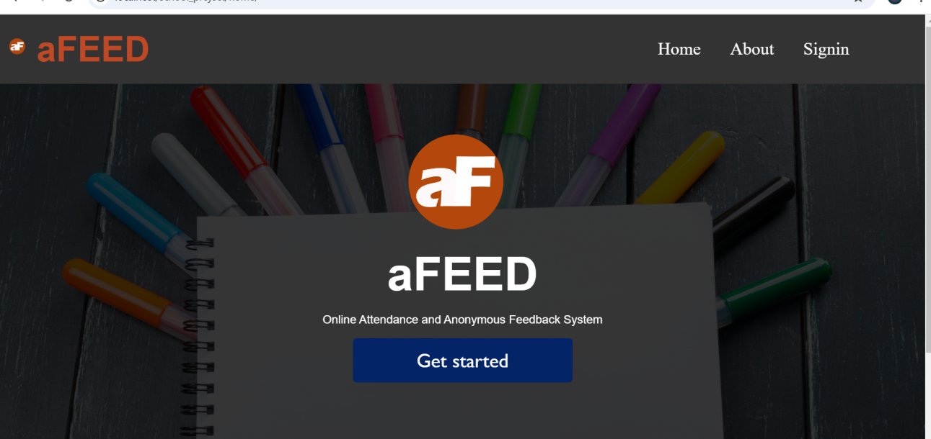The general home page is the first page of the web application for all the actors to  
access the services or features in the platform using their respective logins and passwords that  
give them varying privileges. The types of actors interacting with the system are: the  
admins (superadmin and admin), teachers and students. To obtain the figure for the general home page below, we launch XAMPP control panel, the control panel opens and on the start buttons next to Apache and SQL, click start and wait for the status of the buttons to change to stop. Then open a web browser and type in “localhost/school_project/home/”.

Figure

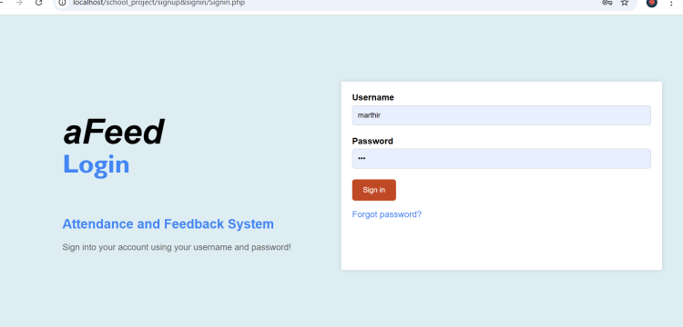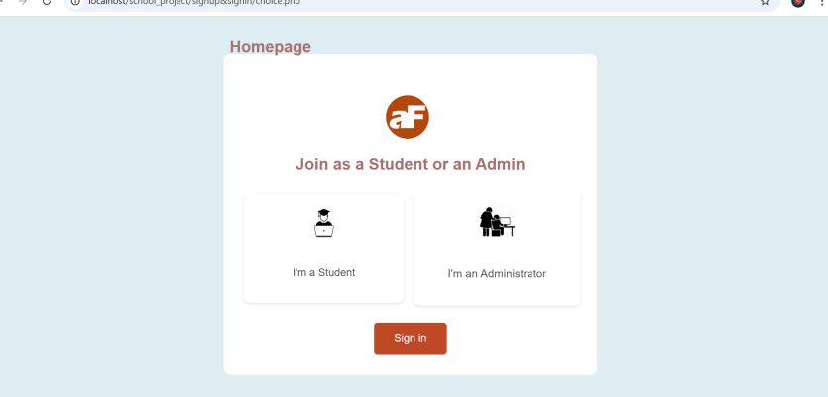

Figure : image of general signin page

## 4.3.2 ACTIVITIES (DASHBOARDS)

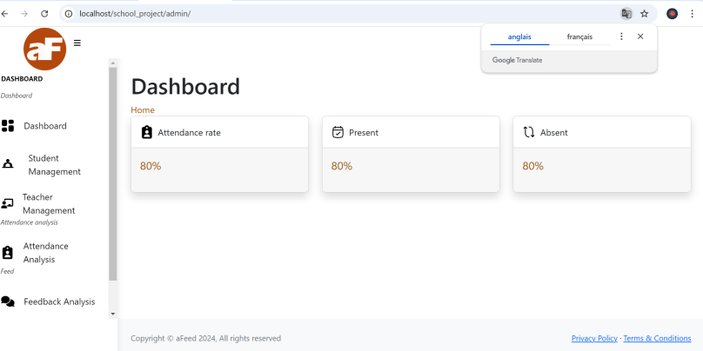When the admins create their account and insert their username or email and password in the spaces provided and click on login, we obtain the administrator’s homepage known as the dashboard, as shown in figure below. On this dashboard, the administrators has the following : Student Managemenet (where administrators can add or remove a student to the system), Teacher Management (where the administrator can add and or remove a teacher from the system), the Attendance Analysis (where administrators see analysis or report on students ) and finally feedback analysis (where admins see feedback written by students).

FIGURE

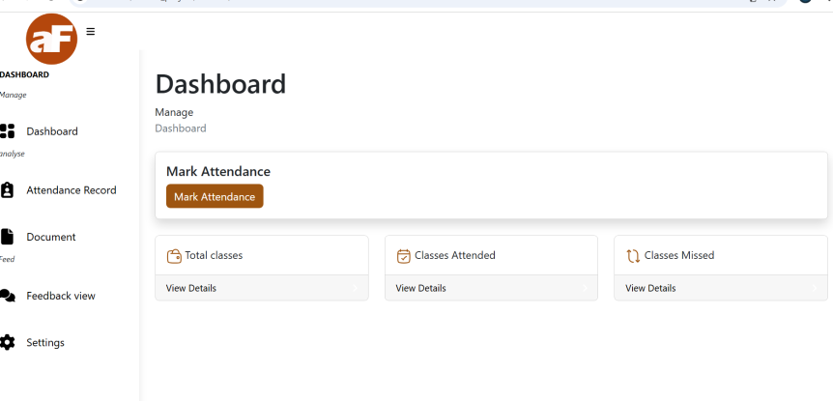When the students login, they are sent to this dashboard where they carry out their various activities. The dashboard contains : the dashboard where they signal their presence by marking on mark attendance, attendance record (where students can see their past attendance), Document ( where students get material uploaded by teachers) and finally feedback view (where students view feedback written by other students and adds their own feedback ) and finally the settings.

FIGURE

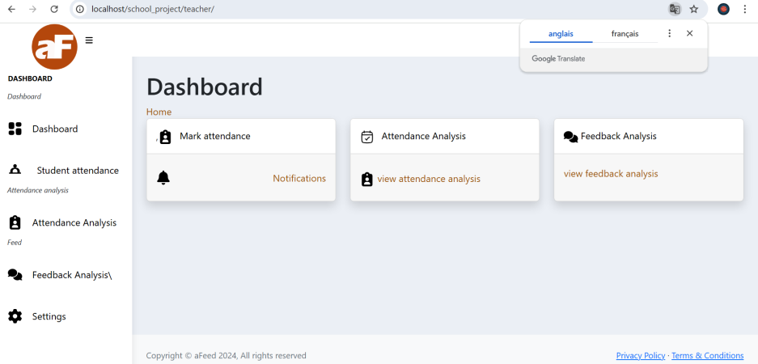When the teachers login, they are directed to this following dashboard where they carry out their various activities. This dashboard contains : the dashboard, the students attendnace ( where he validates attendance marked by students), attendance analysis (where the teacher sees attendace analysis of all the students), documents and finally the feedback analysis (where teachers view feedback written by students and can view the likes and dislikes under each comment).

FIGURE

## 4.3.3 SCENARIO 1: WRITING FEEDBACK BY STUDENT

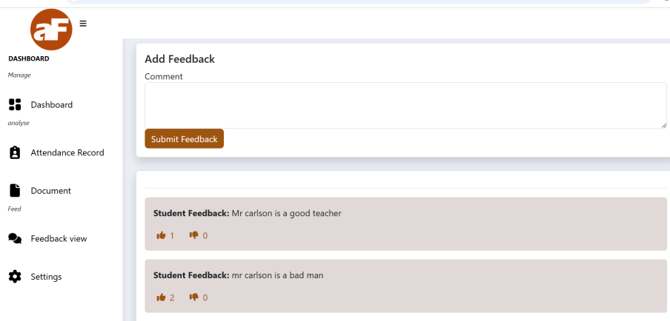In the student’s dashboard, the student has the ability to add feedback on teacher, this is done at the level of the feedback analysis. When a student adds feed, he can publish it where other students see but they don’t see any information partaining to the student that wrote the feedback. Students also have the ability to like and to dislike a comment written by another student.

FIGURE

**4.3.3 SCENARIO 2: ADMIN ADDING A NEW STUDENT TO THE SYSTEM**

The administration also has the possibility to add and remove students from the system. To do that, he goes to manage student (for adding and removing students), there, he will find add student where he just needs to click on it for a form to appear (as pop-up) where he will enter the student’s information and it’ll be saved in the database.

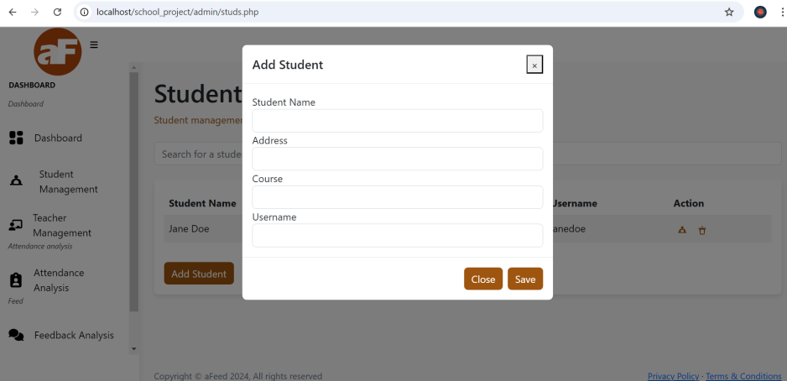

FIGURE